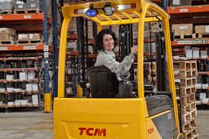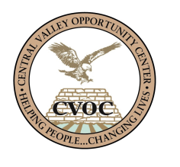

Mrs. Maria Lopez came to CVOC after being laid off from her job of 30 years with Seneca Foods Corporation.  All of those 30 years were spent as a production/line worker and once she was dislocated she felt she needed to seek training that would allow her to move up and earn better pay, while still using the experience she had gained in food production.

Her goals were simply to be able to put her 30 years of experience to use, provide for her family and not live paycheck to paycheck.

After talking to a CVOC case manager and considering the several options available, she decided to enroll in the CVOC Forklift/Industrial Truck Operator Certificate Training.  It was not long before Mrs. Lopez completed her training and received her certificate of completion and operator card.  She then found employment with a local company working in their warehouse as a forklift driver.

Due to the training she received with CVOC, her hard work and faith that she would succeed, Mrs. Lopez is now earning $20 dollars an hour, more than she was as a 30 year production worker at Seneca.

Mrs. Lopez is now able to provide for her family and save some money due to the living wage she now receives. She is very thankful that she found CVOC and their training program.

**Maria Lopez**

**“Thanks to CVOC I’m back to work!”**

**Maria Lopez**

Forklift Driver