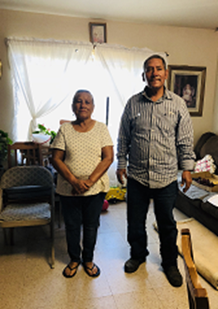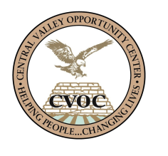

**Josefina Ramirez**

“I can’t give enough thanks to everyone whose hands touched the paperwork that led to my assistance.”

**Josefina Ramirez**

WIA Housing

The WIA-Housing program has touched the lives of many farm workers. Recently we had the opportunity to help Josefina and Panfilo Ramirez, whose income is not stable due to the lack of steady seasonal work. When Josefina saw CVOC’s mobile unit parked at the Westley Migrant Camp on August 29, 2018, she approached the mobile unit to inquire about our programs.

While processing her eligibility documents, we learned that they migrated to the United States from Mexico many years ago, and since then they have work in the fields to support themselves. As is well known, the work in the fields is physically demanding and can take a toll on a person’s body. Josefina knows what it is like when things go from bad to worse. Since last year, she has not been able to work due to her age (she is 69 years old). Furthermore, her husband’s income was reduced by half in that course of time. Adding to their troubles, his unemployment compensation took several months to be approved. As tenants in subsidized housing, they are entitled to have their rent adjusted. However, through a series of administrative errors, the process was delayed, and they found themselves unable to pay the rent for September.

CVOC Case Managers took the necessary steps to make sure Josefina qualified. We then assisted her with the program application. Not only did Josefina qualify for rental assistance under the WIA-Housing program but also qualified for a food voucher under the WIOA-167 program. She expressed her gratitude to CVOC: “I can’t give enough thanks to everyone whose hands touched the paperwork that led to my assistance.”